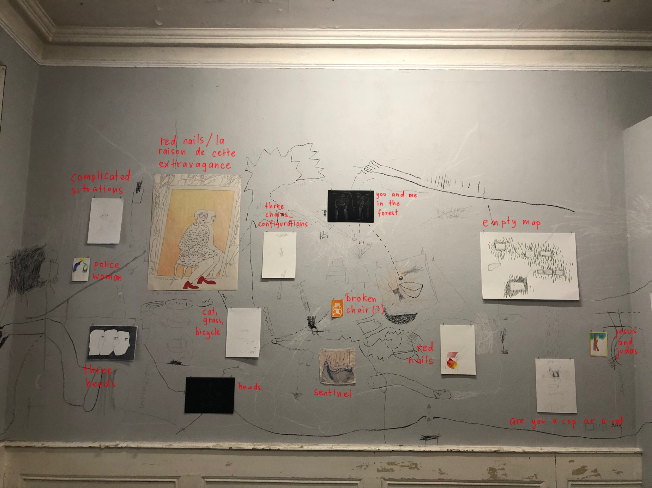

Olivia Abächerli

Line Rime

Olivia Abächerli

Olivia Abächerli

Olivia Abächerli

Line Rime

Line Rime

Line Rime

Line Rime

Line Rime

Line Rime

Isabella Beneduci

Olivia Abächerli

Olivia Abächerli